**REPORT on Dr. Prabhakar Sharmas’ Visit at CIPS department- CHARUSAT University**

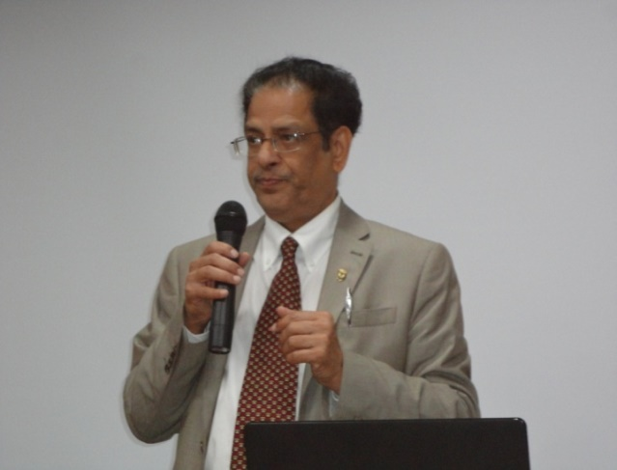‘Research is the foundation of science’ leading to evolution of a researcher, marking his footsteps towards ‘serving mankind’. According to Dr. Prabhakar Sharma, head and professor (nephrology and hypertension division), Department of Medicine, Texas Tech Health Sciences Centre, Texas Tech University, Lubbock, USA, “The objective of research is essentially to gain economic progress, social development and serving humanity.” During his two days interactive session held on 18th and 19th December 2017 at CHARUSAT University, Changa, Anand, Gujarat, he interacted with students and faculties of paramedical division encouraging them for research with a team approach. According to him, team approach is the key to attain a noble work. He elaborated his views on team approach and avenues in allied health care system and highlighted the growing demand of paramedics in health care. The session was co-chaired by Dr. Mohan Rajapurkar, director (research and postgraduate studies, nephrology division), Muljibhai Patel Urological Hospital, Nadiad, Gujarat.

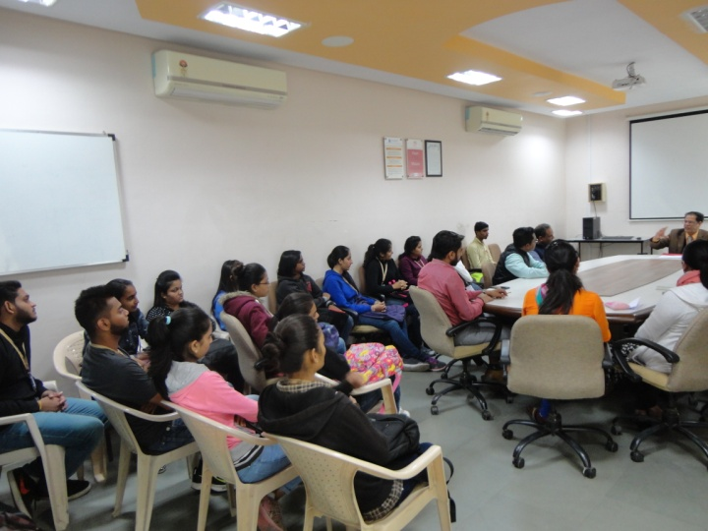On 18th the Provost (CHARUSAT University) welcomed Dr. Prabhakar Sharma and discussed about research and education at CHARUSAT. Then Dr. Prabhakar along with Dr. Darshan (Principal, CIPS) reached the venue (MTIN, auditorium). The session started with formal introduction of Dr. Prabhakar and then he lead the session. He interacted with students and faculties of ARIP, MTIN and CIPS. The theme of the talk was “Team Approach for Comprehensive Health Care”. The session continued for about 2 and half hour and the students as well as faculties attended it with a great interest. He told the students that without team approach there would be no progress. He even discussed that students and teachers are the pillar for the next generation of health care system and in the next generation what is the importance of the paramedics. He showed that in the current scenario there is an extreme need for the Paramedics. He also discussed various opportunities available at university level and how research is the inseparable part of any education system. The session ended with question and answers. Then, as a host we made him visited the whole campus and where he was very much impressed with our Hospital facilities and service. His day ended with lunch where he interacted with principals of various departments and they shared the view about research at both universities.

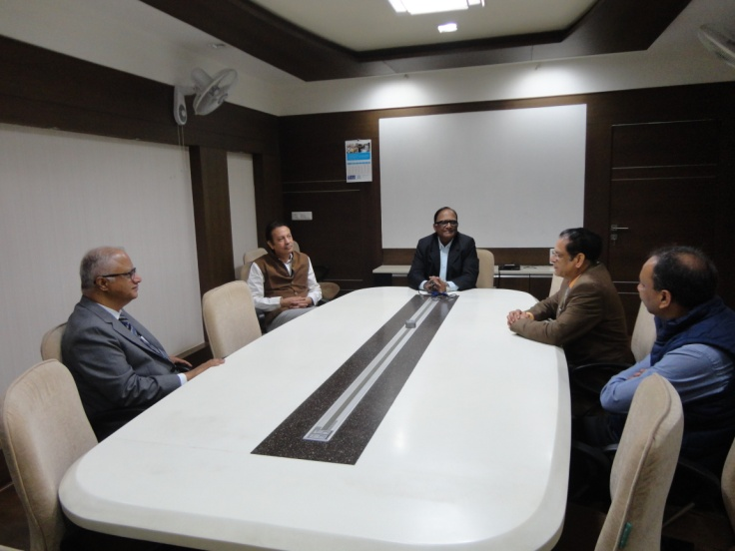The next day 19th started with an elaborative discussion between Dr. B. G. Patel (Provost, CHARUSAT), Dr. Devang Joshi (Registrar, CHARUSAT), Dr. Prabhakar Sharma (Head, Nephrology Division, TTU), Dr. Mohan Rjapurkar (Director, Research Department, Muljibhai Patel Urological Hospital) and Dr. Darshan Patel (Principal, CIPS). All the dignitaries discussed about the research opportunities across the universities and probable MOUs between the universities. Importance of student and faculty exchange programs across the universities. Dr. Prabhakar and Dr. Rajapurkar showed a keen interest in collaborations.

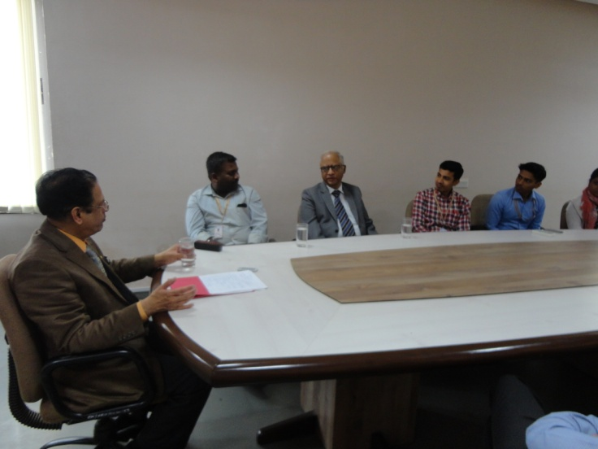After the official meeting Dr. Prabhakar initiated the session at ARIP conference room and Dr. Rajapurkar co-chaired the session. Dr. Balaganpathy (Principal, ARIP) and Dr. Darshan (Principal, CIPS) were also present along with faculties and students of various streams. The topic for interaction was “Research orientation of students and faculties and Avenues for faculty Development in Allied Health Sciences”. The session proved to be a fruitful session in terms of students learning various research opportunities available at various Universities located abroad. The guest constantly emphasized on the importance of research in the development of Universites at global level and role of students and faculty members in research activity. He also discussed the increasing demand of the Allied Health Care Sector. At the end, the session was open for questions and answer. Dr. Rajapurkar also shared his views about research and its importance. Both the invitees explicitly said that research is the heart of any institute and it would be rather recognized only by the research activities it performs.

The two day program was managed by Dr. Dhara Patel (Head, MLT Department, CIPS) under the constant guidance of Dr. Darshan Patel (Principal, CIPS).

The total budget allocated for the program was 40,000 INR. The below mentioned table shows the expenses in details:

|  |  |  |  |
| --- | --- | --- | --- |
| 1. | Arrival from Delhi to Ahmedabad and Departure from Ahmedabad to Hyderabad | 17th December 2017 and 19th December 2017 | 6765 INR |
| 2. | Remuneration for two days 18th and 19th December 2017 (Lectures) | 18th and 19th December 2017 | 10000 INR |
| 3. | Stay for two days at La Casa Inn, Anand | 17th, 18th and 19th December 2017 | 5598 INR |